**Advance Database Management Systems Lab**

**Experiment- 6**

**To understand the concepts of Views**

**Aryan Mohan**

**500092142**

**Batch- 2**

CREATE DATABASE LabExperiment6;

USE LabExperiment6;

CREATE TABLE EMPLOYEES( Employee_id VARCHAR(10) NOT NULL PRIMARY KEY, First_Name VARCHAR(30) NOT NULL, Last_Name VARCHAR(30) NOT NULL, DOB Date, salary DECIMAL(25,0) NOT NULL, Department_id VARCHAR(10) );

--1 Create View of name emp_view and the column would be Employee_id, Last_Name, salary and department_id only.

CREATE VIEW emp_view(Employee_id, Last_Name, salary, Department_id) AS SELECT Employee_id, Last_Name, salary, Department_id FROM EMPLOYEES;

exec sp_columns emp_view

Output:



--2) Insert values into view(remove the NOT NULL constraint and then insert values)

ALTER TABLE EMPLOYEES ALTER COLUMN First_Name varchar(30) null;

INSERT INTO emp_view VALUES('EMP000111', 'JAIN', 50000, 'INFORMATIC');

SELECT * FROM EMPLOYEES;

INSERT INTO emp_view VALUES ('EMP000112', 'Joyce', 25000, 'ECE');

INSERT INTO emp_view VALUES ('EMP000113', 'Ramesh',38000, 'ME');

INSERT INTO emp_view VALUES ('EMP000114', 'James', 55000, 'CIVIL');

INSERT INTO emp_view VALUES('EMP000115','Jennifer',65555, 'IT');

SELECT * FROM EMPLOYEES;

SELECT * FROM emp_view;

Output:

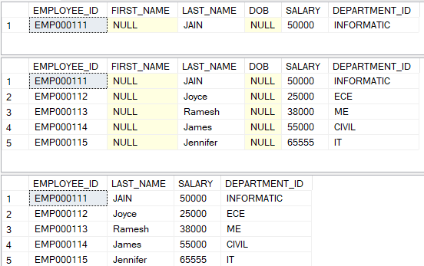

--3) Modify, delete and drop operations are performed on view.

--UPDATE

update emp_view set salary=60000 where Employee_id='EMP000113';

DELETE FROM emp_view WHERE Last_Name='Joyce';

SELECT * FROM emp_view;

CREATE VIEW ADBMS(L_Name, salary) AS SELECT Last_Name, salary FROM EMPLOYEES;

SELECT * FROM ADBMS;

DROP VIEW ADBMS;

Output:

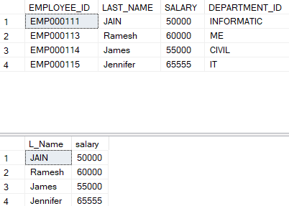

---4 Creates a view named salary_view. The view shows the employees in department and their annual salary.

SELECT * FROM emp_view;

INSERT INTO emp_view VALUES('EMP000116','GUPTA',80000, '20');

CREATE VIEW salary_viewB1 AS SELECT Employee_id, Last_Name, salary FROM EMPLOYEES WHERE Department_id='20';

SELECT * FROM salary_viewB1;

Output:

